Ingrams Time Systems Pty Ltd
ABN 50 129 539 251 ACN 129 539 251
12/21 Eugene Terrace Ringwood VIC 3134 Australia
P 03 9876 0066 F 03 9876 0055 E sales@ingrams.com.au W www.ingrams.com.au

Standard Wireless Clocks Specifications

300mm Dial Standard Wireless Clock Specifications
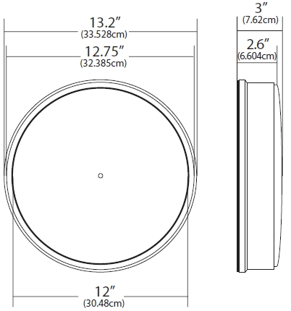
- Heavy Duty Construction
- Durable ABS Casing or Aluminium Casing
- Poly carbonate Lens (shatter resistant)
- Battery (2 D-Cell) or Electric 230 Vac
- Battery Life Expectancy – 5 years
Rear Case Diameter: 13.2″ (33.528cm)
Front Case Diameter: 12.75″ (32.385cm)
Dial Graphics Diameter: 12″ (30.48cm)
Edge Thickness: 2.6″ (6.604cm)
Center Thickness: 3″ (7.62cm)

400mm Dial Standard Wireless Clock Specifications
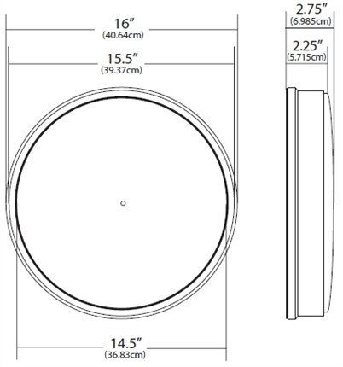
- Heavy Duty Construction
- Durable ABS Casing or Aluminium Casing
- Poly carbonate Lens (shatter resistant)
- Battery (2 D-Cell) or Electric 230 Vac
- Battery Life Expectancy – 5 years
Rear Case Diameter: 16″ (40.64cm)
Front Case Diameter: 15.5″ (39.37cm)
Dial Graphics Diameter: 14.5″ (36.83cm)
Edge Thickness: 2.25″ (5.715cm)
Center Thickness: 2.75” (6.985cm)
Ceiling and Side Mount Dimensions: 3″ H x 4.5″ D (3.62cm H x 11.43cm D)

300mm (33.02cm) and 400mm (40.64cm) Rear View
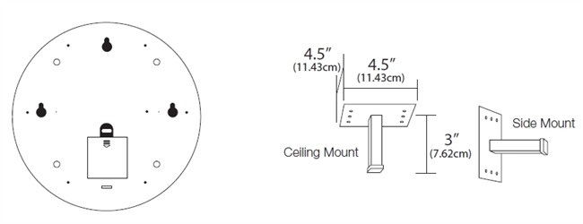
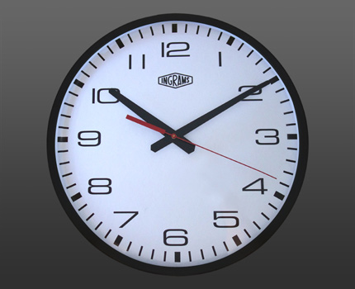
Standard Wireless Clock
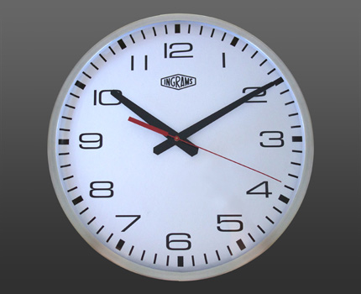
Aluminium Wireless Clock

